Software Requirements Specification

Version 1.0

May 26, 2021

Online voting system

إبراهيم الخوري

موسى باخص

نضال بلال

Contents

1.0. Introduction 3

1.1. Purpose 3

1.2. Scope of Project 3

1.3. Glossary 4

1.4. References 4

1.5. Overview of Document 4

2.0. Overall Description 5

2.1 System Environment 5

2.2 Functional Requirements Specification 6

2.2.1 candidates Use Cases 6

2.2.2 voter Use Cases 7

2.3 User Characteristics 10

2.4 Non-Functional Requirements 10

3.0. Requirements Specification 10

3.1 External Interface Requirements 10

3.2 Functional Requirements 11

3.3 Detailed Non-Functional Requirements 14

# 1.0. Introduction

## 1.1. Purpose

The purpose of this document is to present a detailed description of the online voting system. It will explain the purpose and features of the system , the interfaces of the system, what the system will do, the constraints under which it must operate and how the system will react to external stimuli. This document is intended for both the stakeholders and the developers of the website.

## 1.2. Scope of Project

This software system will be a online voting system for the countries that will use it instead of the traditional way of election, especially under the current situation of covid19 . This system will be designed to help voters to choose their candidates easy and fast .So people will vote from their homes by one click and the candidates can present themselves and their plans directly to voters using this system

More specifically, this system will be an easy way for voters to choose their candidates without any reason to be afraid of covid19

## 1.3. Glossary

|  |  |
| --- | --- |
| **Term** | **Definition** |
| Online voting system | Software that make voters be able to choose their candidates easy and fast via internet |
| Online voter | voter that has logged in the system |
| Online candidate | Candidate that had been added to the database of the system |
| Online id | A way that use to confirm the identity of every voter |
| Votes counter | A way that use to calculate the number of votes for every candidate in the database |

## 1.4. References

IEEE. *IEEE Std 830-1998 IEEE Recommended Practice for Software Requirements Specifications.* IEEE Computer Society, 1998.

## 1.5. Overview of Document

The next chapter, the Overall Description section, of this document gives an overview of the functionality of the product. It describes the informal requirements and is used to establish a context for the technical requirements specification in the next chapter.

The third chapter, Requirements Specification section, of this document is written primarily for the developers and describes in technical terms the details of the functionality of the product.

Both sections of the document describe the same software product in its entirety, but are intended for different audiences and thus use different language.

# 2.0. Overall Description

## 2.1 System Environment

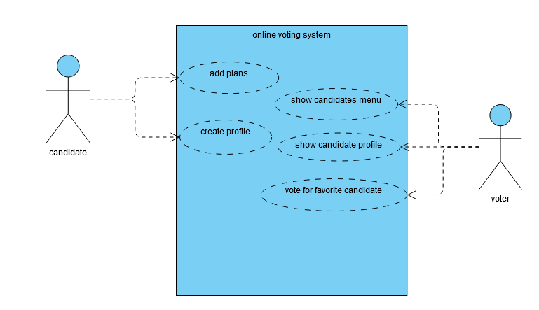

Figure 1 - System Environment

The online voting system has a lot of voters and candidates .

The candidates can create their personal profile and add their plans

The voters can show the candidates menu and enter to the candidate profile and vote for their favorite.

## 2.2 Functional Requirements Specification

This section outlines the use cases for each of the candidates and voters

### 2.2.1 candidate Use Cases

#### Use case: create profile

**Diagram:**

candidate

Create profile

**Brief Description**

The candidate can create their personal profile in the website of the system after login

**Initial Step-By-Step Description**

Before this use case can be initiated, the candidate has already accessed the online voting system .

1. The candidate has to login to the website to confirm his/her identity
2. The system will confirm the identity of the candidate using his/her ID
3. The candidate click create profile button on my profile page after login
4. The candidate has to upload a personal picture for this profile
5. The system will give the right name for the profile using the information of the candidate which the system will find it in the database of the system

#### Use case: Add plans

**Diagram:**

candidate

Add plans

**Brief Description**

The candidate can add his/her plans to the profile after create it.

**Initial Step-By-Step Description**

Before this use case can be initiated, the candidate created a profile .

1. The candidate click Add plans Button to open Add plans Form.
2. The candidate enter the headline of the plan
3. The candidate explain this plan in 3-4 lines
4. The system add these plans into the profile of the candidate

### 2.2.2 voter Use Cases

#### Use case: show candidates menu

**Diagram:**

voter

Show candidates menu

**Brief Description**

The Student can show the candidates menu by click the Show Menu button

**Initial Step-By-Step Description**

Before this use case can be initiated, the voter must log in the website.

1. The voter enter his/her information and click the login button on the main page of the website
2. The system will confirm the identity of the voter using the information in the database
3. The voter click the show menu button
4. The system will show the full candidates menu to the voter

#### Use case: show candidate profile

**Diagram:**

voter

Show candidate profile

**Brief Description**

The voter can show candidate profile by click the show profile button on the right of each candidate name in the candidates menu

**Initial Step-By-Step Description**

Before this use case can be initiated, the voter must show the candidates menu

1. The Student choose any candidate and click the show profile button that belongs to this candidate
2. The system will ask the voter to choose the language that will be used to show the information of the profile
3. The system will show the chosen profile with all the information and plans that belongs to this candidate

#### Use case: vote for favorite candidate

**Diagram:**

voter

Vote for favorite candidate

**Brief Description**

The voter can vote for his/her favorite candidate by click the vote button in the profile of this candidate

**Initial Step-By-Step Description**

Before this use case can be initiated, the voter must enter to the profile of the candidate

1. The voter click the vote button in the profile of his/her favorite candidate
2. The system will increase the number of votes for this candidate in the database
3. The system will show a “ thank you for voting “ message for the voter

## 2.3 User Characteristics

The voter is expected to be able to use web browsers.

The main screen of the online voting system will have full instructions and information about the voting system

The candidate profile page will have the information and plans of the candidate

The candidates menu page will have the names and the ages of all candidates

## 2.4 Non-Functional Requirements

The online voting system will be on a server with high speed Internet capability. The software developed here assumes the use of a tool to connect with database and a tool for Real Time communication.

# 3.0. Requirements Specification

## 3.1 External Interface Requirements

This system needs to interact with any web browser on any operating system to enable the user to interact with the website.

In addition, it requires communication with MongoDB database in order to store and retrieve data for the voter and the candidate .

## 3.2 Functional Requirements

3.2.1 Create profile

|  |  |
| --- | --- |
| **Use Case Name** | Create profile |
| **Trigger** | The candidate select to create a profile |
| **Precondition** | The candidate is inside *my profile page* on the website after login. |
| **Basic Path** | 1. The candidate click on *create profile* button . 2. The system displays windows which contains *Create profile* Form to enter his/her information . 3. The candidate enters the information and submits the form 4. The candidate has to upload a personal picture for this profile 5. The system checks that required fields are not blank . 6. The system will give the right name for the profile using the information of the candidate which the system will find it in the database of the system 7. The system store this profile in the database |
| **Alternative Paths** | In step5, if any required field is blank , the candidater is instructed to add an entry . |
| **Postcondition** | The profile has been stored in database . |
| **Exception Paths** | None |
| **Other** | None |

3.2.2 add plans

|  |  |
| --- | --- |
| **Use Case Name** | Add plans |
| **Trigger** | The candidate select to add plans for his/her profile |
| **Precondition** | The candidate is on his/her profile page on the website |
| **Basic Path** | 1. The candidate click Add plans Button on his/her profile 2. The system displays windows which contains *Add plans* Form to enter plans information . 3. The candidate enters the information and submits the form 4. The system checks that required fields are not blank . 5. The system add these plans to the profile of the candidate. 6. The system store these plans in the database |
| **Alternative Paths** | In step 3, if any required field is blank , the candidate is instructed to add an entry . |
| **Postcondition** | The plans have been stored in database . |
| **Exception Paths** | The candidate may abandon the operation at any time . |
| **Other** | None |

3.2.3: Show candidates menu

|  |  |
| --- | --- |
| **Use Case Name** | Show candidates menu |
| **Trigger** | . The voter can Show candidates menu |
| **Precondition** | **:** the voter must log in the website |
| **Basic Path** | 1. The voter click the show menu button on the main page after login 2. The system will show the full candidates menu to the voter 3. The voter can discover the content of the menu |
| **Alternative Paths** | In step 1, if the login information isn’t correct the system will not show the show menu button for the voter |
| **Postcondition** | Showing the full candidates menu on the screen |
| **Exception Paths** | None |
| **Other** | none |

3.2.4 Show candidate profile

|  |  |
| --- | --- |
| **Use Case Name** | Show candidate profile |
| **Trigger** | . The voter can Show candidate profile |
| **Precondition** | the voter must show the candidates menu |
| **Basic Path** | 1. The voter choose a candidate from the candidates menu 2. The system will ask the voter to choose the language that will be used to show the information of the profile 3. The system will show the chosen profile with all the information and plans that belongs to this candidate |
| **Alternative Paths** | In step 2, if the voter didn’t choose a language then the system will show the profile in English as a default language |
| **Postcondition** | watch the chosen candidate profile |
| **Exception Paths** | None |
| **Other** | none |

3.2.5 : Vote for favorite candidate

|  |  |
| --- | --- |
| **Use Case Name** | Vote for favorite candidate |
| **Trigger** | . The Student can vote for his/her favorite candidate |
| **Precondition** | the Student must enter to the profile of the candidate |
| **Basic Path** | 1. The voter click the vote button in the profile of his/her favorite candidate 2. The system will increase the number of votes for this candidate in the database 3. The system will show a “ thank you for voting “ message for the voter |
| **Alternative Paths** | none |
| **Postcondition** | Increase the number of votings for every candidate in the database |
| **Exception Paths** | The voter may abandon the operation at any time |
| **Other** | none |

## 3.3 Detailed Non-Functional Requirements

3.3.1 High speed Internet

The online voting system will be on a server with high speed Internet capability.

3.3.2 Real Time Communication

Because we don’t want any error in the process of increasing the number of votes in the database